**Youth Program**(1 hour)

God’s Blessings are Always With You

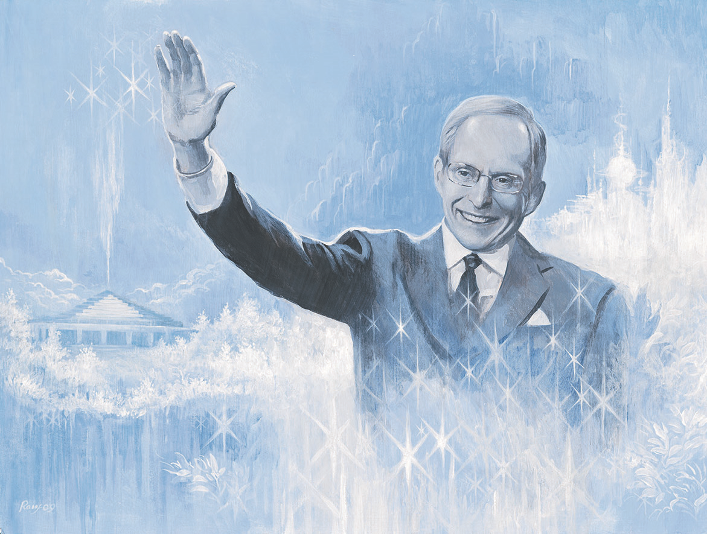

|  |  |
| --- | --- |
| **Event Date:**  **Time:**  **Where:**  **Ages:** 5-10  **Large Group Facilitator**: Click or tap here to enter a name.  **Small Group Facilitators**: Click or tap here to enter names. | **Supplies Needed**  **For Welcome Activity**   * Name tags * Markers * Blessing signs * Large popsicle sticks/craft sticks * Glue * Pictures of ECK symbols and the Mahanta   **For Parable Activity**   * Blessing signs * PowerPoint slides for *Pappagena Come Home Illustrated ECK Parable*   **For Blessings Hopscotch**   * Numbered squares for hopscotch * Bean bags |

**Spiritual Purpose and Benefits:**

* Youth are invited to practice noticing more of God’s blessings in their lives.
* Youth explore how God’s blessings help us and what they can teach us.

**Set Up Notes:**

To save time during the program, cut out the blessing sign templates for youth, both the back and front sides. Create a sample sign.

Set up one short hopscotch board (see illustration in Appendix A) for every 5 children expected to attend.

* Option 1: Use carpet sample squares with a number painted or taped onto each square.
* Option 2: Use painters tape to outline the hopscotch boards on the floor.
* Option 3: Go outdoors to play the game and use chalk to draw the boards.

Each hopscotch board will need a marker, such as a bean bag.

|  |  |  |
| --- | --- | --- |
| **Time** | **Activity Steps** | **Notes** |
| 10-15  minutes, depending on what time children arrive | **Welcome Activity**   1. **Small Group Facilitators**: Greet children and invite them to choose a seat at the table and decorate a name tag. 2. Youth make a blessing sign (see image in Notes) by drawing, writing, or gluing images of things they are grateful for on the back, attaching a craft stick as a handle, then gluing on the front. |  |
| 5 minutes | **Introduction and HU Song**   1. **Large Group Facilitator:** invite children to sit as a group in chairs or on the floor. Youth bring their blessings signs with them. 2. *Today we are talking about blessings and how God’s blessings are always with you*. *You wrote blessings you are grateful for on the back of your blessings signs. You can turn to a neighbor and share some of your blessings.* 3. *Thinking about blessings opens our hearts. So does singing* HU! *As we sing* HU *today, you can silently say, “thank you Mahanta for these blessings in my life.” Notice how you feel after you say it.* 4. Lead youth in a *HU* song and brief contemplation. | Slide 1 |
| 20  minutes | **Listening for Blessings in an ECK Parable**   1. **Large Group Facilitator:** *When we have a problem, it can be hard to see the blessings in that problem.* Share a brief, youth-friendly personal example of a problem and its blessings. 2. Share that one of the greatest blessings we have in Eckankar is the Mahanta, who can help us see God’s love for us and help us see the blessings in our challenges. 3. *We’re going to use our blessing signs today to practice listening and watching for blessings in a story. As we read the story together, look for a blessing and raise your blessings sign each time you notice one. If you want to share what you noticed, keep your sign up* (demonstrate). 4. *As you listen, see if you can notice any hidden blessings in the story. If another person says the same blessing that you noticed, use your hand like this to show that you noticed the same one.* (Hold up hand with thumb and pinky finger out, point thumb towards self and pinky towards the other person, and move hand back and forth) 5. If needed, go over expectations for keeping the signs to ourselves and respecting others’ space. 6. Using the slide show, read *Pappagena, Come Home.* The volunteers may read, or children may take turns reading. 7. When a child keeps a blessings sign up, call on the child to share. Towards the end of the story, if attention is wandering, acknowledge that children are noticing blessings with a nod, and keep reading instead of stopping frequently to share. 8. At the end of the parable, invite youth to turn and talk to a neighbor. *What do you think this story is teaching us?* 9. Share answers in the large group. | Note: gestures are used to encourage active participation  Slides 2-14 |
| 20 minutes | **Blessings Hopscotch**   1. *Has anyone heard of the golden contract before?* 2. If no one is sure what it means: *The golden contract is our agreement as Soul that every experience we have is part of our spiritual journey to lead us home to God. Each experience teaches us something important and brings blessings into our lives. Sometimes these blessings are hard to see.* 3. *We’re going to play a game called Blessings Hopscotch.* 4. Give the instructions: *In Blessings Hopscotch, you think about simple blessings in your life. Think about a little thing that brings you some light or happiness. Maybe you don’t usually pay attention to it. By looking at it as Soul, you can see it as a blessing.* Give a couple personal examples of simple blessings in your life. 5. *On your way back through the board, share how the blessing helped you.* 6. *The next time you go through the game, share something that may not seem like a blessing at first, like in the story we read today.* 7. The youth remain seated while a volunteer uses one of the hopscotch boards to demonstrate how to play (see Appendix A for detailed instructions). 8. Divide youth into small groups with at least one volunteer per group. Youth take turns hopping through the board and saying blessings in their lives and how the blessings helped them. 9. If time allows, invite youth to add variations or create new rules. Later, in the large group, they can share their versions of the game. |  |
| 5 minutes | **Closing**   1. **Large Group Facilitator:** *Did anyone come up with new ways to play Blessings Hopscotch that you would like to share?* 2. *Did anyone think of something that may not seem like a blessing at first, but actually helped you grow? Would you like to share?* 3. Lead a closing HU song 4. Have youth help clean up the room. |  |

**Appendix A: Blessings Hopscotch Set Up and Instructions**

1

3

2

4

HOME

**Supplies Needed:**

* Numbered squares, large enough to hop on (see diagram above)
* Bean bags to toss onto the board

**Overview:** In Blessings Hopscotch players follow the traditional rules of hopscotch while pausing to share the blessings in their lives. The board is shorter than traditional hopscotch.

**How to Play:** Players hop from square to square while trying to keep their balance and not stepping on any lines. Players skip over a different square each time they hop through the board. When in the middle of the board (squares 2 and 3) players share a blessing from their lives.

**Step by Step Directions:**

1. The first player tosses a bean bag onto square 1. They jump over square 1 without touching it so that their left foot is in square 2 and their right foot is in square 3, without touching any of the lines between the squares.
2. The player shares a simple blessing in their life – something they don’t usually pay attention to.
3. The player then hops on one foot onto square 4 without touching any lines and staying on one foot.
4. The player jumps into the Home box with both feet. Then the player jumps to turn around and face square 4.
5. The player hops on one foot onto square 4, and then jumps to have one foot in square 2 and one in square 3. The player shares how the blessing from step 2 helped them.
6. The player picks up their bean bag from square 1 and the jumps over square 1 and off the board.
7. If the player loses balance or jumps on a line, their turn is done. For their next turn, they try again, skipping square 1.
8. If the player completes a turn successfully, on their next turn they toss their bean bag onto square 2 and complete the course without touching square 2.
9. This time for square 3 they share a blessing that came from a problem in their life. On the way back they share how that blessing helped them.
10. Repeat these steps, alternating the type of blessing shared, until everyone has shared four or more blessings in their lives.

**Easier version**: it is fine to step on a line and to jump and stand with both feet, if needed for younger children.