Adventures in the Light and Sound of God

Date: _________________
Ages 11-13

When
Where

Program Description
Did you know the Light and Sound are ways God speaks to you? You can experience the Light and Sound for yourself. Open your inner eyes and ears, and have fun exploring this awesome spiritual secret!

Spiritual Purpose and Benefits
- Youth explore what the Light and Sound of God means and learn that It is the Voice of God, the ECK.
- Youth have fun exploring many ways they can experience the Light and Sound and the benefits of doing so, including more love, joy, and inner guidance.

Program Overview
- Pre-Session Volunteer Meeting
- Welcome Activity – Light and Sound Conversation Starter
- HU Song and Group Meeting
- Fun Facts and Treasure Hunt
- Choose a Spiritual Exercise Adventure
- Craft: Light and Sound Mobile
- Backup Activity (use as needed): ECK Sound Current Charades
- Clean Up, Sharing, and Feedback

Pre-Session Volunteer Meeting
- Introductions and HU Song
- Brief review of volunteer roles
- Safety review
- Program review
- Questions and answers

Welcome Activity — Light and Sound Conversation Starters (15 minutes)
Supplies
- Completed Conversation Starter sample, one per table
- Handout: Light and
Sound of God Conversation Starter
- Markers
- Scissors

- Group Leaders welcome youth as they arrive and give them a copy of the handout. Show youth a completed activity sample.
- Youth can color the words, numbers, shapes, and spaces as they like. Then they cut out the large square on the dotted line.
- Show youth how to fold the conversation starter, following the steps available here:
https://www.youtube.com/watch?v=jEHSSllIv1g
- Youth can use the conversation starter in pairs or small groups by following these steps:
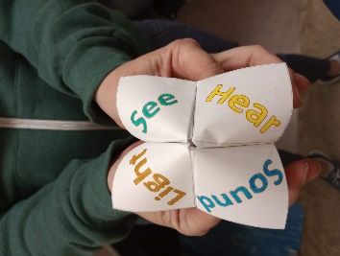
  - Everyone introduces themselves.
  - Hold the conversation starter as shown in the photo to the right.
  - Invite your conversation partner to choose one of the four words written on the outside squares.
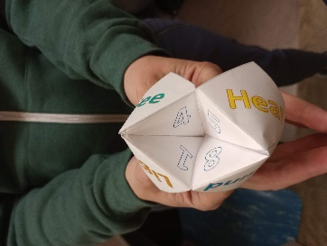
  - Spell that word out loud, one letter at a time. As you say each letter (for example L-I-G-H-T), open and then close the four corners. Open the top and bottom for the first letter, then right and left for the next letter, and so on.
  - Keep your Conversation Starter held open when you say the last letter.
  - Invite your conversation partner to choose one of the numbers that are visible on the inside triangles.
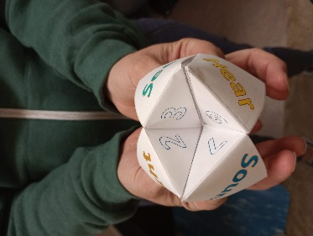
  - Count out loud up to the chosen number, while opening and closing the Conversation Starter for each number you say.
  - Keep it held open when you say the last number.
  - Invite your conversation partner to again choose a visible number. Then unfold the tab with that number on it.
  - Read the question that goes with the number they chose. Then invite your conversation partner to respond, and share your own answer to the question.

Welcome, HU Song, and Group Meeting (15 minutes)
Note to Group Leaders: Please sit with youth during the large group HU and Guidelines/Rules.
- Youth and volunteers come together in a large circle.
- The Room Leader welcomes the youth.
- Introduce the session theme: You probably guessed from the welcome activity that today we are talking about the Light and Sound of God. They are the Voice of God, speaking to you.
- We are going to have fun exploring how to open our inner eyes and ears so that you can experience the Light and Sound for yourself, in your own way.
- Explain what the HU is and how it can help us open our inner eyes and ears to the Light and Sound.
- Lead the group in a HU song. Invite them to look for light and listen for any sounds they may see and hear.
- Afterwards, ask “Did anyone have an experience they’d like to share?”
Ground Rules
- The Room Leader invites youth to participate in creating ground rules for behavior and respect in the youth room. Invite youth to help come up with any missing rules by asking questions, such as, What about cell phones?
- Write the ground rules on a flip chart or white board, to refer to later as needed.
- Like following the rules in a game, when everyone plays by the agreed upon rules, the game is a lot more fun!
Supplies
- Handout: Fun Facts About the Light and Sound
- Pencils and pens
- Posters of ECK artwork showing the Light and Sound, hung up around the room (each with an answer from the Fun Facts handout written on it ahead of time in invisible ink that can be seen with
a UV light pen—see Set-up Instructions)
- Small UV light flashlights, one for each youth
Fun Facts and Treasure Hunt (30 minutes)
- The Activity Leader introduces the activity: We’re going to do a cool activity to discover some fun facts about the Light and Sound of God. You can work by yourself or with a friend.
- Youth sit at tables. Group Leaders give youth the Fun Facts handout. Youth fill in the blanks with their best guesses.
- After most youth complete the handout, the Activity Leader explains the next step: The ECK teachings are sometimes called secret teachings. This is because you have to go within yourself to meet with the Inner Master and to experience the Light and Sound. This is what the spiritual exercises help us do!
- Now you get to do a treasure hunt to discover the answers to your handout— just like you can do spiritual exercises to find spiritual truths for yourself.
- You probably noticed the artwork we have around the room today. These were created by ECK artists and show inner experiences with the Light and Sound.

- There is more to this artwork than you can see with just your eyes!
- The Activity Leader shows youth how to shine a UV light on one of the posters to reveal a fun fact. We experience the Light and Sound of God with inner eyes and ears. In this treasure hunt, you can shine your special light on these posters to find the spiritual treasure that is hidden on each of them.
- Group Leaders pass out the UV flashlights to youth. Youth can walk around the room and look at the art pieces in any order to find the secret messages, check their answers, and make any changes they’d like to make to their Fun Facts handout.
- As they finish the treasure hunt, youth return to sit at their tables. Group Leaders collect the flashlights.

- Group Leaders lead a brief discussion about the treasure hunt.
? Questions can include:
  - Which fun facts did you already know? Which ones were new to you?
  - Which fun facts are the most interesting to you?
  - Did you relate to any of the experiences shown in the art work?

Choose a Spiritual Exercise Adventure (20 minutes)
Supplies
- Spiritual Exercise Signs, placed in the center of 5 tables
- Handout: A Golden Elevator
- Handout: A Diamond’s Reflection
- Handout: The Eternal Nature of Soul
- Handout: Your Cup of Living Water
- Handout: Beyond Limitations
- The Activity Leader introduces the activity: There are many amazing things that can happen when you experience the Light and Sound of God, like having more love, joy, or inner peace, receiving spiritual help, and having spiritual adventures.
- Just like your Fun Facts handout says, the way to experience the Light and Sound more often is by doing spiritual exercises. You can do a spiritual exercise for any reason that is interesting to you.
- Today we have five spiritual exercises that you can choose from.
- Give youth a brief description of the five exercises to choose from:
  - If you would like to take a Soul journey to the God worlds, you may like “A Golden Elevator.”
  - If you would like an exercise that brings blessings, strength, and love, you may like “A Diamond’s Reflection.”
  - If you would like to experience being Soul as a body of light, you may like, “The Eternal Nature of Soul.”
  - If you would like to have an experience with the ECK, the Light and Sound, as Living Water, you might like “Your Cup of Living Water.”
  - If you would like help with a challenge or limitation in your life, or with a situation that feels stuck, you may like, “Beyond Limitations.”

- Youth choose an exercise by going to sit at the table that has a sign for that exercise.
- Group Leaders at each table give youth the spiritual exercise handout and then lead youth in trying the exercise, allowing youth time to have their own experience.
- Group Leaders invite youth to share what happened when they tried the exercise, if they wish to share.
- The Activity Leader wraps up the activity: You can keep working with these exercises on your own at home. Spiritual exercises take practice, and many people need a quiet space on their own to help them focus. The more types of spiritual exercises you try, the more you will see what kind works best for you. You can experiment, change them, and even make up your own!

2:20 – 2:30 p.m. Break – Get a drink of water, use restroom, chat with each other, etc.

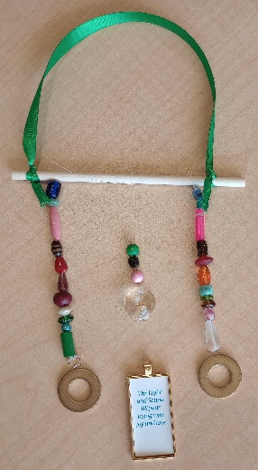
Craft — Light and Sound Mobiles (45 minutes)
- Youth sit in a large group.
- The Activity Leader introduces the activity: We’re going to make mobiles that remind us of the Light and Sound, God’s love in action. You can hang yours up at home or give it to someone as a gift.
- Show youth the sample mobile.
- When light shines through the beads and the prism, it creates different colors of light, like rainbows made by the prism. If you hang it up in a place with a breeze or gently move it, the metal washers will make a nice ringing sound.
- You can choose a phrase about the Light and Sound or a Mahanta star to add to the middle of your mobile, in a little hanging frame.
Supplies
- Sample mobile
- Mobile kits with:
  - 6-inch wooden dowel rods or sticks
  - Ribbon
  - String
  - Beads
  - Small glass chandelier prisms (20mm) with 2 holes
  - Brass or colorful metal washers
  - Frame-shaped pendants
- Scissors
- Handout: Phrases about the Light and Sound
- Glue
- Youth move to sit at tables.
- Group Leaders give each youth a mobile kit and the handout: How to Make a Mobile. Group Leaders and youth help each other with tying the string as needed.
- Youth follow these steps to make a mobile:
  - Tie the ribbon on both ends of the 6-inch wooden dowel rod for hanging up the mobile at home.
  - Tie three lengths of string onto the wooden rod, an equal distance apart.
  - Add beads to right and left strings and knot the strings two times to secure the beads, leaving extra string after the beads.
  - Use the extra string after the beads to tie on a washer on the right and left sides. Knot the string two times. If trimming, leave at least 2 inches of string, or it will come loose easily in the future.
  - On the middle string, add a few beads an inch or two down the string, then tie on a prism, using two knots.
  - Next, tie string in the bottom hole of the prism, and then tie on the frame-shaped pendant (knot it two times).
  - Choose either a phrase about the Light and Sound or a Mahanta star to cut out and glue in the frame.
- Have youth put their mobiles in their zip-top bag to take home.
Backup Activity: ECK Sound Current Charades
(use as needed for youth who finish their mobile early)
Supplies
- ECK Sound Current Charades word cards, cut out and in a bag
- A timer (can use the Activity Leader’s cell phone)

- The Activity Leader introduces the activity: We are going to play a game of Charades that is all about the Sound Current. You may remember that your Fun Facts handout included the fact that the Sounds of God can be heard in any outer sound as well as inner sounds. You might recognize these sounds everyday around you.
- Does anyone have an example to share of what these sounds could be?
- The Activity Leader shares the following quote:
“The ECK Sound Current…can be heard within outer sounds like the humming of a refrigerator or air conditioner. It is in the sound of the wind in the leaves, falling rain, thunder of jets, singing birds, and the awful rumble of a tornado. Again, Its sound can be heard in laughter, weeping, the din of city traffic, ocean waves, and the quiet rippling of a mountain stream. It can also be heard as an inner sound.”
—Harold Klemp, The Wonder Within You, p. 157
- Let’s see which of these sounds come up in our game of Charades!
- The Activity Leader demonstrates how to play:
  - Choose a card from the bag. Each card has a Sound written on it. Don’t show anyone else the card you chose.
  - Act out that sound to everyone else, only using actions. Youth guess what Sound is being acted out.
- Explain that youth shouldn’t use words or noises, point at an object, or mouth the word silently.
- Show youth these hand gestures to use during the game:
  - You can hold up fingers to show how many words are written on the card. For example, hold up two fingers for the phrase “bird singing.” Everyone guessing can then say, “two words,” to show they understand.
  - Then, to show which word in the phrase you are acting out, hold up one finger for the first word or two fingers for the second word.
  - Demonstrate taking a card, holding up two fingers, followed by holding up two fingers again. Youth should respond by saying, “Two words,” and then “Second word.”
  - To act out a word that sounds like or rhymes with your word, tap your ear, and then act it out. When you tap your ear, everyone should respond by saying, “Sounds like…”
  - For example, if the word on your card is “Soul”, you can try acting out a word that rhymes with it. Demonstrate by tapping your ear, youth should respond by saying, “Sounds like…” and then act out the word “roll” by rolling your arms forward.
  - Point at the youth who guessed correctly. You can point at someone who says the correct rhyming word to show they got it right.
- Youth play the game. The first youth to guess the Sound of God that is being acted out takes the next turn to choose a card and act it out.

Clean Up, Sharing, and Feedback (15 minutes)
- Youth help clean up the room.
- Youth sit in a large group.
- Room Leader invites youth to share whatever they’d like to about their experience that afternoon.
- Room Leader asks for feedback on the activities they did that day, and ideas of what else the youth might want to do in future programs.
? Questions to ask can include but aren’t limited to:
- What did you like doing today?
- What could make it even better?
- What kinds of activities would be fun?
- What spiritual things would you like to learn about?

