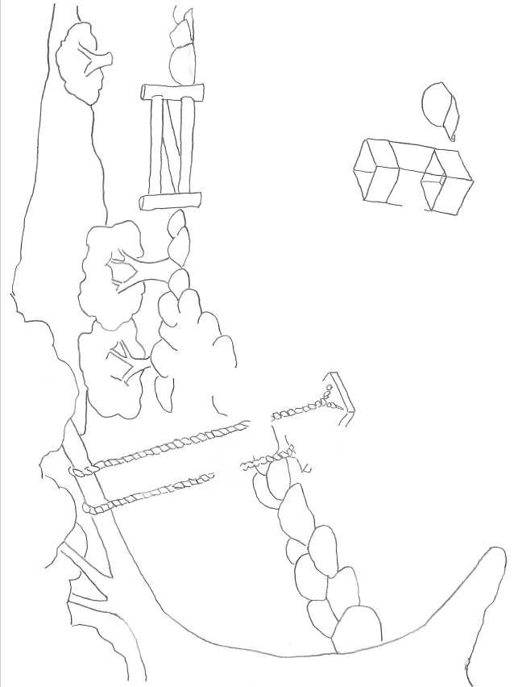

How ECK Helps Me

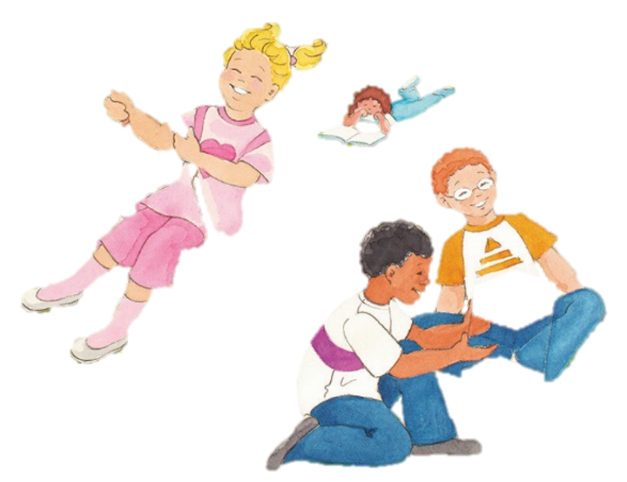

An activity book made by:

Soul is on a journey home to God.

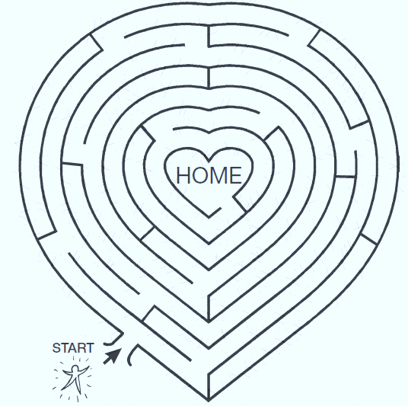

The Mahanta is our guide  
 on this adventure.

**HU helps us…**

Ask three people how the HU helps them. Then add your own idea!

**The Mahanta helps me…**

Glue your favorite picture of the Master here.

Write ways the Mahanta helps you on this page.

**Spiritual exercises help me…**



In the speech bubble, write one or two ways the spiritual exercises help you!

A spiritual exercise  
I can try:

Glue a spiritual exercise to try here.

**ECK Helps Me…**

Fill this page with ways ECK helps you. Glue some and add your own!