**My Parenting Question   
for the Master**

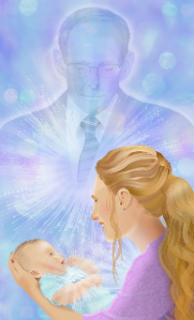

**DONATION AND RELEASE**

1. I hereby release and donate all right, title, and interest (including all copyrights) in and to the following work to ECKANKAR, a California nonprofit religious corporation or its successors or assigns:

_________________________________________________________________________________

Title of work ("the work")

____________________Parenting Questions for the Master_________________________

Description of the work: Manuscript, song, writing, article, etc.

1. The work is my own original work. It contains no defamatory or unlawful matter, and it and my donation in no way infringe upon the copyrights or violate the privacy or property rights of any other person. I agree to indemnify and hold ECKANKAR harmless from any suit, demand, or claim made against it by reason of the use, performance, presentation, display, publication, or distribution of the work.
2. Upon my signing this Donation and Release, ECKANKAR shall become the sole owner of the donated work, which includes ownership of all copyrights to the same, and all other interests including but not limited to (a) my reproduction rights, adaptation rights, distribution rights, and display rights to and for the work and (b) the right to digitize the work and reproduce the work either identically or in modified form from the digitized form. ECKANKAR may revise and use the work at its sole discretion in all media now known or later devised.
3. This Donation and Release is an irrevocable gift to ECKANKAR. I do not expect to receive any moneys, fees, royalties, or other consideration in regard to this gift. I release ECKANKAR from any liability to me with regard to the work and its use by ECKANKAR or any other party.
4. This Donation and Release is governed by the laws of the state of Minnesota and, as applicable, by the laws of the United States of America.

**I have read all of the above and agree to it.**

Name _______________________________________________ ________________________________  
 signature printed name

ECK ID# ____________________________________________ Date _________/_________/_________  
 mo. day yr.

______________________________________________ ECK ID#____________________

Signature of parent or legal guardian if person signing is under 18 years old