**Your Family and the World of Dreams**

Family Workshop: 1 hour

Click or tap here to enter a time.

Click or tap here to enter a location.

Facilitators: Click or tap here to enter text.

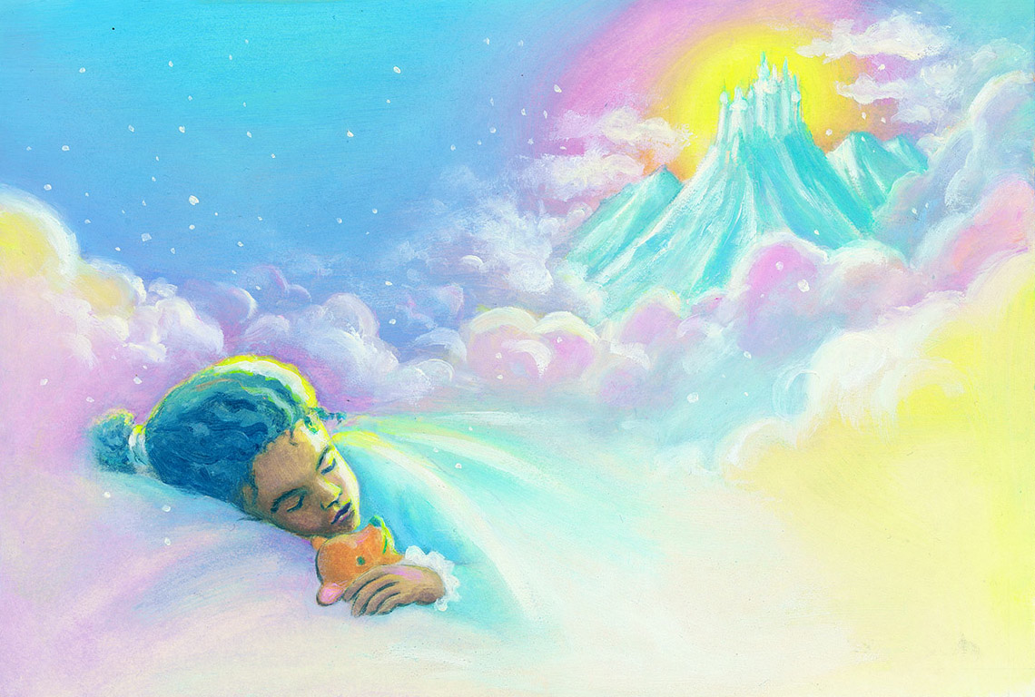

**Supplies Needed:**

* ECK activity sheets
* Handout: Dream Journal
* Handout: Dream Storyboard and Challenging Dream (double sided)
* Handout: How Did Your Dream Make You Feel?
* Handout: Inviting the Dream Master
* Small gift bag for each table, containing dream symbol objects (see attached list and picture)
* Dream Cards (cut apart and sorted into separate envelopes for each dream)
* Markers and pens
* Scissors
* Stickers
* Glue sticks

|  |  |
| --- | --- |
| **Spiritual Purpose:**   * To give families the opportunity to understand that their dreams are a gift from the ECK that can help them understand themselves and make their lives better. * To show families how they can work with the Dream Master. * To encourage families to share their dreams with each other and demonstrate the value of keeping a dream journal. | |
| **Spiritual Benefits:**   * Understanding that dreams bring can give a greater sense of Sugmad’s love for each Soul. * Sharing dreams within a family can create a greater spiritual connection with one another and with the guidance, insight, and assistance the ECK and the Mahanta offer us in our daily lives. | |
| Facilitator Name | **Step by Step Action Plan** |
|  | Welcome families as they arrive.  Youth may do the ECK activity sheets provided at the tables before the workshop begins and throughout the workshop as they like. |
|  | **Welcome & Introduction** (3 minutes) **(Slide 1)**  Share Quote: **(Slide 2)**  “Your dreams are like a telescope that can give a better view of something that is normally out of reach: your spiritual side. That includes how you act, feel, reflect, think, react, and even love.”  -Sri Harold Klemp  *The Art of Spiritual Dreaming,* p. 3 |
|  | **Sound of Soul: HU** (5 minutes)  *Harold Klemp, the Mahanta, the Living ECK Master is also known as the Dream Master. He is a spiritual guide that can help you understand your dreams if you ask.* **(Slide 3)**  **IntroduceVideo Clip from *Dream Journeys*** (on ECKANKAR website, minutes1:18-2:35***)* (Slides 4-6)**  “Begin remembering your dreams to get an idea of who and what you are as Soul. Because you will have…you’ll see things. You’ll gain wisdom. Sometimes you go to Temples of Golden Wisdom where some of the ECK Masters will be teaching you in the dream state and they’ll be giving you spiritual exercises. These exercises can help you travel further into the dream worlds or get deeper insights into the secret laws of life.  “In other words, you may get a better understanding of the Law of Cause and Effect. Not the fact that it exists, but how does it work out in your everyday life? It helps you…the dream state can help you to see a cause that has occurred in your life maybe two, three weeks ago and the effect that is now showing up today or in the last day or so. And you begin to put two and two together, and you realize from this that most of the misery or happiness that you have in your life today, you have made for yourself.”  *By singing HU, our Love Song to God, we can receive guidance, protection, and understanding. We invite you to join us in this love song to God.* **(Slide 7)** |
|  | **Kinds of Dreams** (13 minutes)  **Facilitator or invited youth shares a dream that has helped her/him in  her/his life.** (If possible, it is nice to invite a youth to participate in this way, with their parent present).  *There are many different kinds of dreams. The dream just shared illustrates a dream that came to help her/him understand what to do in a life situation. It was giving guidance.*  *How many of you have had a dream that helped you and gave you guidance?*  *You’ll see in your Dream Journal there is a place to keep track of the kinds of dreams you have had and dreams you would like to have.* (Show journal). *Let’s take a few moments to look at some different kinds of dreams.*  Facilitator holds up a dream card and describes the type of dream.  *Who has had a dream of flying?* (show of hands) *Who would like to have a dream of flying?* (show of hands*). Your* ***Table Facilitator*** *will give you a dream card for a flying dream and you can glue it in your journal under “Dreams I’ve Had” or “Dreams I Want to have.”* Show the dream journal page for each*.*  *Who has had a dream that seemed vivid and real?* Continue as above for each type of dream, with **Table Facilitator** passing out the various dream cards.   * + Dreams of departed loved ones   + Dreams that seem vivid and real   + Waking up in your dreams   + Dreams where you received guidance to help you in your life   + Dreams of a far-off, yet wonderful places   + Dreams of past lives   + Prophetic dreams--dreams that let you see something that will happen   + Dreams of protection--from guardian angels or spiritual guides--refer to the images of ECK Masters on **slide 8**. *These spiritual guides are always available to answer your questions and help you. Have any of you seen any of these guides in your dreams?* |
|  | **Dream Symbols** (2 minutes)  *Have you ever had a dream that didn’t make any sense and everything was all jumbled? Sometimes we dream in symbols. We all have different experiences in our lives, so the symbols we have in our dreams are ones only we can interpret.*  *Example: Say you’ve got a pet snake at home, and you love your pet snake! His name is Bernie. But I’m scared of snakes, because I almost got bit by one on a walk in nature. If you had a dream with a snake, it would be a positive symbol, one of love, since you have a pet snake. But, I have always been afraid of snakes. So, if I had a snake in my dream, it might mean, “watch out, be careful!” So, I’d watch my outer life for the “snake” that Spirit might be warning me about. Do you see why only you can interpret your dream symbols?* |
|  | **My Dream Dictionary** (5 minutes)  *So it’s a good idea to keep track of your dream symbols.*  *Sri Harold shares more about this in his book* The Dream Master: **(Slides 9-10)**  “Creating a dream dictionary can help you become familiar with your own dream symbols. Whether a baseball diamond, a bear, an eagle, or anything else, you’ll know immediately what that particular symbol means to you….  “As you create your own dream dictionary of symbols, record the date next to the meaning of each symbol. This way you can keep track as the meaning changes. As you unfold, your dream symbols are going to take on different meanings, a fact generally not known by people who study dreams.”  -Sri Harold Klemp  *The Art of Spiritual Dreaming,* p. 167  *There is a place in your Dream Journal where you can record your dream symbols as you remember them, and what they mean. It’s on the page called “My Dream Dictionary.”*  Hold up journal and explain the dictionary is in the back of the journal. |
|  | **Table Facilitator:**  Invite a participant at your table to reach into the small gift bag with objects for dream symbols. Ask the participant to hold up their object. Ask the whole table, *if you had this in your dream, what would it mean to you?* They call out what it might mean*. With this meaning, what kind of spiritual guidance would this symbol be giving you?* Comment on how many interpretations came from this one item.  Have another participant pick another item and ask the table to call out what it might mean. *With this meaning, what kind of spiritual guidance would this symbol be giving you?*  Do this a third time. Point out again, how one item can have so many meanings, because we all have different experiences.  Invite everyone at your table to record the meaning of their symbols in their dictionary. |
|  | **Spiritual Exercise** (5 minutes)  **Facilitator**  *The next activity will give you a chance to work with the Mahanta to try to understand a dream using a storyboard* (Show storyboard*). On one side of the storyboard you can use the suggestions and questions to gain greater understanding of a dream, and on the other side you can take a look at a challenging dream you may have had, including the scary dreams we sometimes have.*  *How many of you have had a dream that you just didn’t understand? It didn’t make sense to you and maybe it still doesn’t? We can**ask the Mahanta, the Dream Master to help us understand what it might mean or shine a light on another dream that needs a deeper understanding.*  *As we sing HU now, invite the Mahanta, the Dream Master to work with you, and watch for pictures that come to mind that could give you a clue about the dream you want to work with.*  Lead everyone in a HU Song. |
|  | **Dream Storyboard** (20 minutes) **(Slide 11)**  *Now let’s create a Dream Storyboard. One side of the storyboard shows ways to begin exploring your dream. The other side gives some ideas for working with the Dream Master to understand a challenging dream so we can learn the spiritual lesson or receive the spiritual gift the dream is offering us.*  **Table Facilitators** hand out Dream Storyboards.  *So think of a dream you’d like to understand better. You can share this with your family, if you like.*  *Then select a dream card that best describes what kind of dream you felt your dream might be and paste it onto your Dream Storyboard.*  **Table Facilitator**  If necessary, the Table Facilitator walks through each question on both sides of the Dream Storyboard:   * *How did the dream make you feel?* **Show Emoji handout to work with.** * *What were you doing in your dream? You can draw an action picture*. * *What do you think the symbols in your dream might mean*? *You can write these down in your dream journal as well*. * *What do you think the dream might be about? How does it relate to your life?* * *What might Divine Spirit or the Dream Master be telling you or teaching you through the dream?*   For Learning from Challenging Dreams, the storyboard has more questions to explore your dream further:   * *What made you uncomfortable in the dream?* * *What would you do differently in your dream to help you feel more love?* * *What dream symbols were in your dream? What do you think they mean?* * *Write a story of how you would change your dream.*   Facilitator gives 5-minute warning to complete Dream Storyboards. |
|  | **Whole Group Sharing** (5 minutes)  **Facilitator**  *If you would like, we would love to have the youth share their storyboards at this time!*  If youth are too shy, a parent can share for them, with their child’s permission. |
|  | **Closing and Next Steps** (2 minutes)  *We have a final quote about dreams that we’d like to share* **(Slide 12).** *While I read it, would you be so kind to fill out the evaluation form your* ***Table Facilitator*** *is passing out?* |
|  | “Dreams touch every level of our life. They may let us glimpse the future, or give suggestions for healing, or share insights into our relationships. Above all, they can and will steer us more directly toward God.”  -- Harold Klemp, *The Art of Spiritual Dreaming,* page 2  *When you wake up in the morning, imagine you have a telescope and are looking at your dreams. You can use your Dream Storyboard and your Dream Journal to help you discover the meaning of your dreams. If you like, you can share your dreams with your family.*  *We have a little gift to leave with you. It’s a spiritual exercise calling* Inviting the Dream Master *from* The Spiritual Exercises of ECK, p. 23 **(Slide 13)**.  *You can do this spiritual exercise before going to bed and ask our inner guide to show us how solve a problem, what do we need for a healing, or go to some amazing places.*  *Thank you so much for coming today. We hope you were able to gain some insights into your dreams.*  **Table Facilitators** pass out spiritual exercise handout: “Inviting the Dream Master.” |
|  | Thank you! **(Slide 14)**  Collect evaluation forms please. |